Shrinky Jewelry

If you grew up in the 80's, like I did, you're probably already familiar with the awesomeness that is Shrinky Dinks...but did you know that you can still buy Shrinky Dinks? Yep, they're still out there - in craft stores, hobby shops, and even on Amazon. But you don't have to buy a Shrinky Dink kit to have all the fun. Just look for #6 plastic containers and you can make your own!
Here's a quick fun project! You don't need to be able to draw more than a doodle, and you end up with pretty & interesting jewelry!
These charms can be used for earrings, necklaces, or whatever you'd like. They are made out of plastic recycled from a to-go container (#6 plastic). The directions below are for 2 matching ones, which could be earrings. Because plastics & pens vary, you might start out with a test piece so see how much your plastic will shrink, and how your colors come out. Or just jump right in! It's only trash.

Step 1: Materials
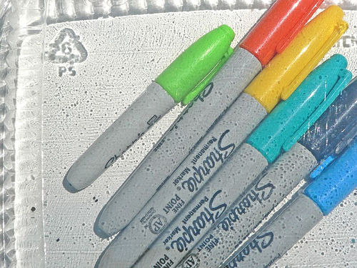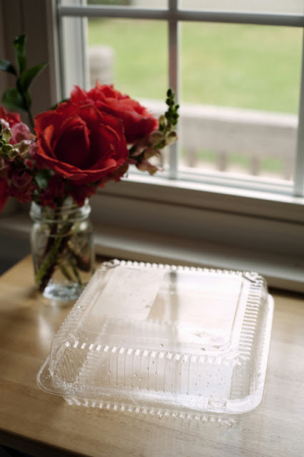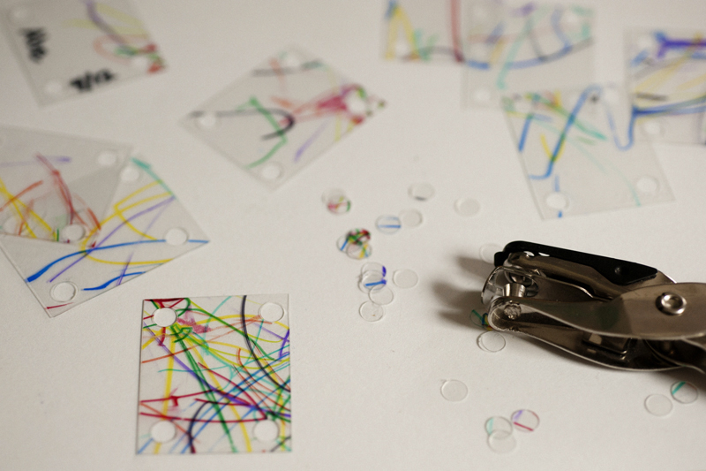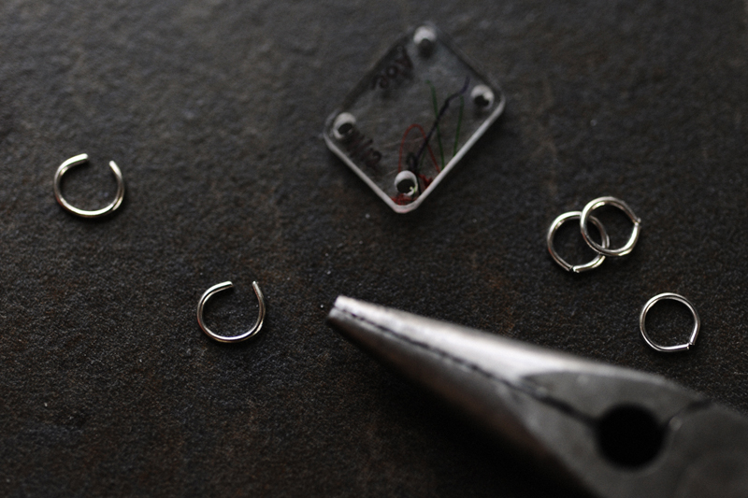
Plastic: It needs to be marked #6. Many to-go containers seem to work. Look for the number inside the recycling triangle. I used salad to-go boxes from my local pizza place.
Sharpie Markers in a variety of light colors, plus black.
Scissors
6mm “jump rings”
Pliers (to open & close “jump rings”
Nail clippers
Hole punch
Toaster (or regular) oven, preheated to around 250 degrees F
Clear nail polish or Polyurethane for sealing (optional)

Step 2: Cut it out!
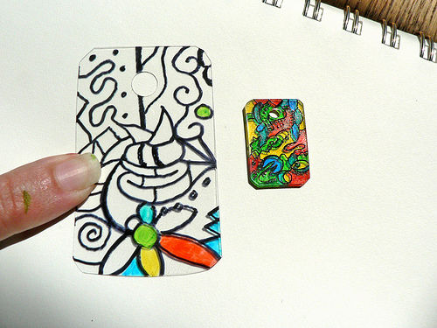
Cut out pieces of the flat parts of the plastic container in the size/shape you want. Mine was about 3 inches x 2 inches. You could also do circles or other shapes, but you need to round off any corners using nail clippers because corners will get sharp when shrunk. (note: all plastic doesn't melt the same and keep the same proportions, so cut both pieces running the same way. e.g. if you're doing 2 rectangles, cut out one large rectangle and cut it in half to ensure your pieces run the same way. If you're doing circles, be sure to mark the top and put your holes in the same place.)
If there is any impressions on the plastic (like the #6 symbol, or words) you can just color over it and it will go away in the shrinking process. But be aware it may be a pain to color or draw lines over.
On each one, use a hole punch to make a hole in the top center.

Step 3: Draw your doodle, and color it!
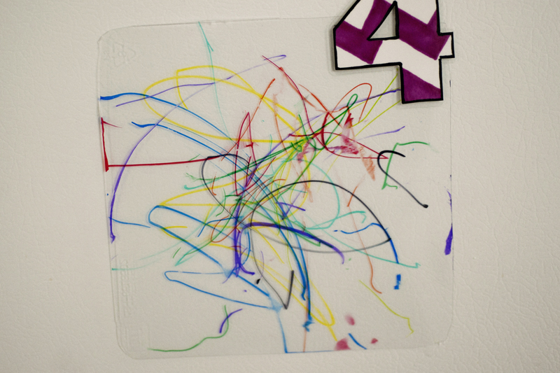
Draw your doodle design on each one with the black sharpie. The designs don't need to be the same, and be creative. Just a series of shapes and doodles. If you're nervous about drawing it, practice on a spare piece. And you can always draw something on paper and trace it on to the plastic. Remember, shrinking hides a multitude of sins!
Randomly color in the design using a variety of light colors. Colors get way more intense when shrunk. The black will smear if you touch another color to it, so be careful. Again, shrinking will hide most issues.
Alternately, draw your design on the front, and turn over the plastic. Color it on the back! You won't have to worry about smearing your black design. However, make sure you don't leave any gaps between your colors (ie, color over all the black lines!) Otherwise you'll have gaps in the color when shrunk. You could also color the whole back in one color if you want to go simple.

Step 4: Time to cook!
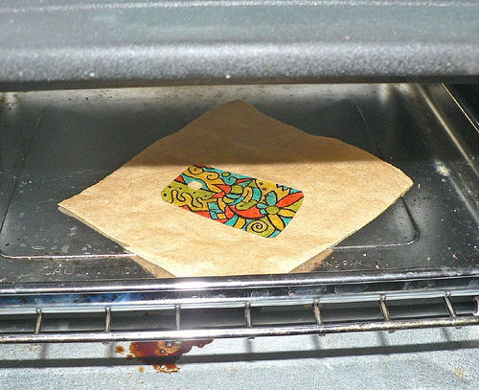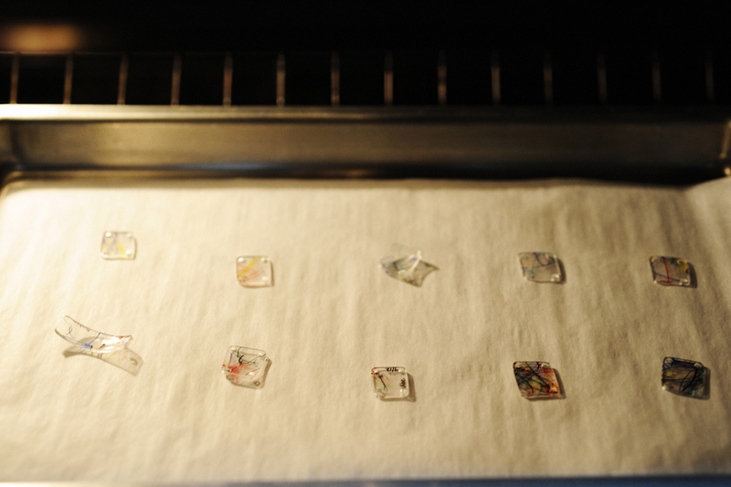
Place your colored piece on a square of parchment paper, on a tray in your toaster oven (preheated to about 250 degrees). Watch the magic happen! Don't worry... it will curl up. and curl up again. then finally settle down to the smallest size.
If your oven is already hot, this will happen almost immediately and take maybe 30 seconds to complete the process. Keep watching!
Sometimes, if you have a long skinny piece, it may turn on it's side and curl up. That's fine, just flatten it out when it's done.

Step 5: Remove from oven
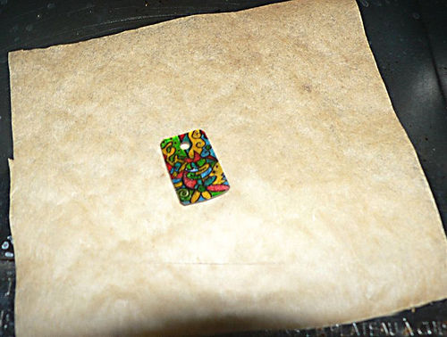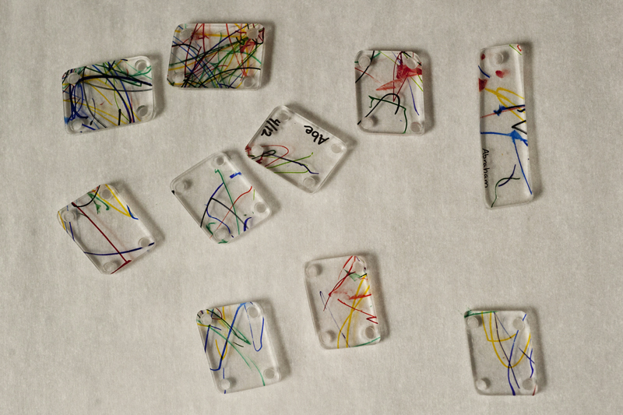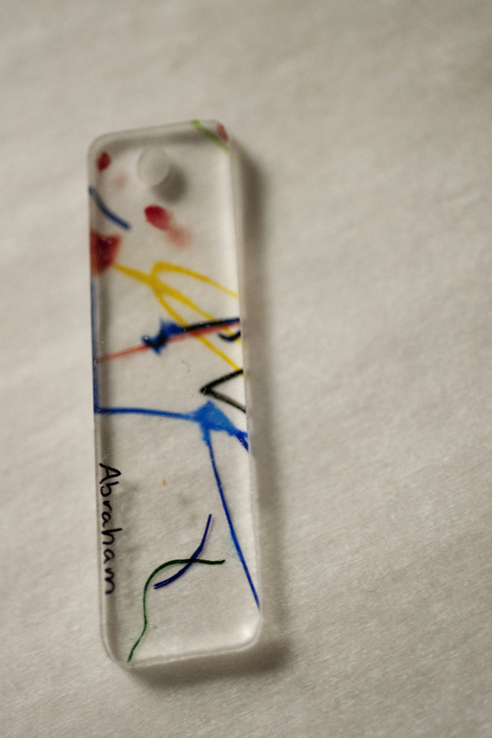
Caution! It will be hot!!
If it's not quite flat at the end, you can press it down flat immediately. Note, depending on your plastic, it may not be quite the same proportions as you started with.
www.instructables.com

